CS 147, Multimodal Interfaces to Broaden Access
Low-fi Prototyping & Pilot Usability Testing

ALTogether

alt

Value Proposition
Creating richer, more reliable alt text

Mission Statement
Our goal is to increase overall awareness about accessibility needs for the visually-impaired by guiding individuals to share accessible content on Instagram.

Problem / Solution Overview
Blind and visually impaired users often feel frustrated with the lack of focus, context, and emotion in auto-generated alt text on Instagram. ALTogether promotes richer and more reliable alt text by providing sighted users a scaffolded way to personally write quality alt text by modifying AI-generated suggestions on their images before posting. ALTogether not only encourages sighted users to adopt alt text practices, but also motivates followers to do the same through social incentives.

Team Members

  Haeli B. |   Danielle C. |   Jung-Won H. |   Sydney J.
Sketches

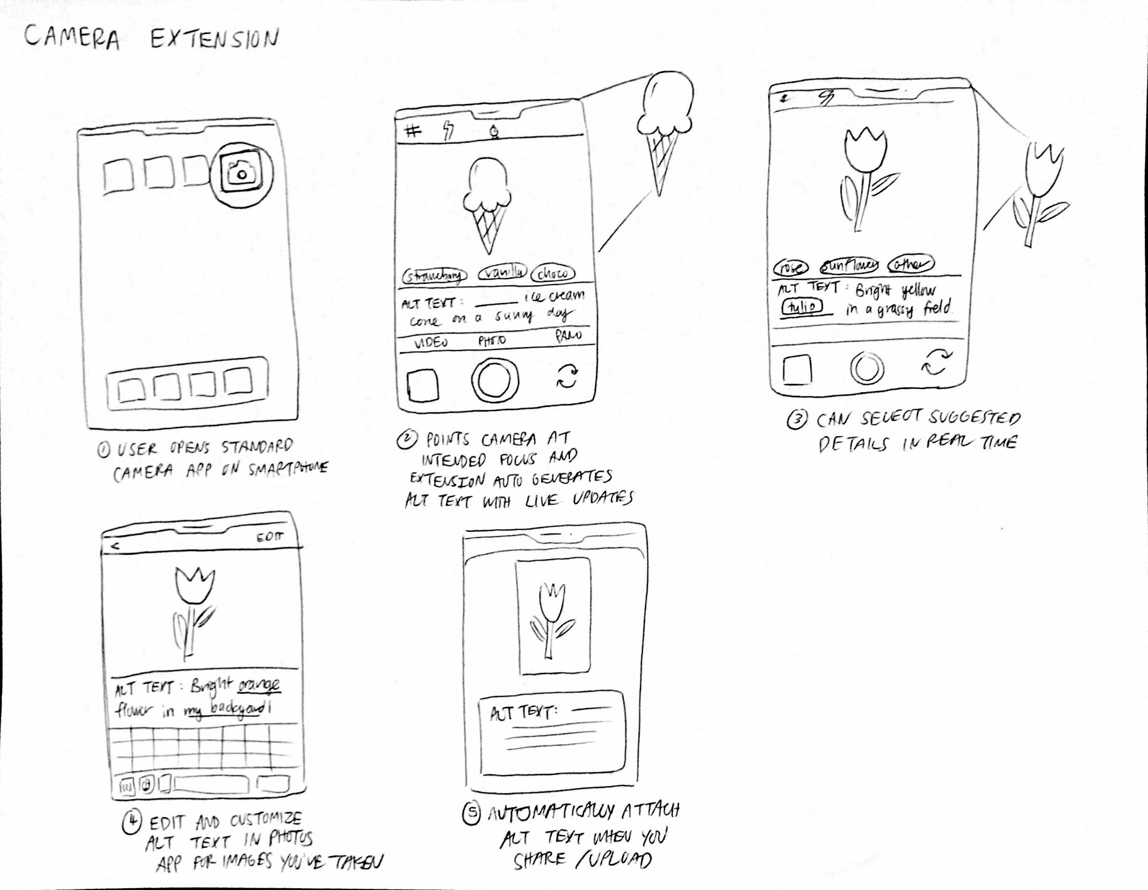
Figure 1: Camera extension that auto-generates alt text suggestions as you point your camera at different objects in real time.

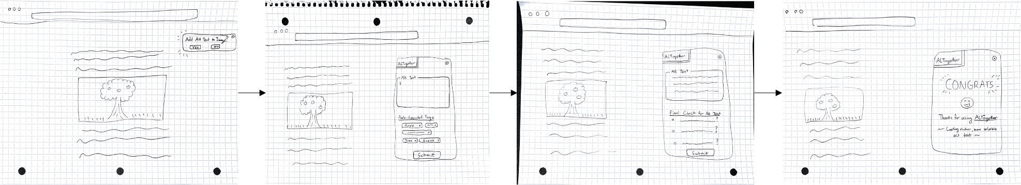
Figure 2: Desktop extension which prompts you to add alt text as you upload an image and walks through the process of writing it.

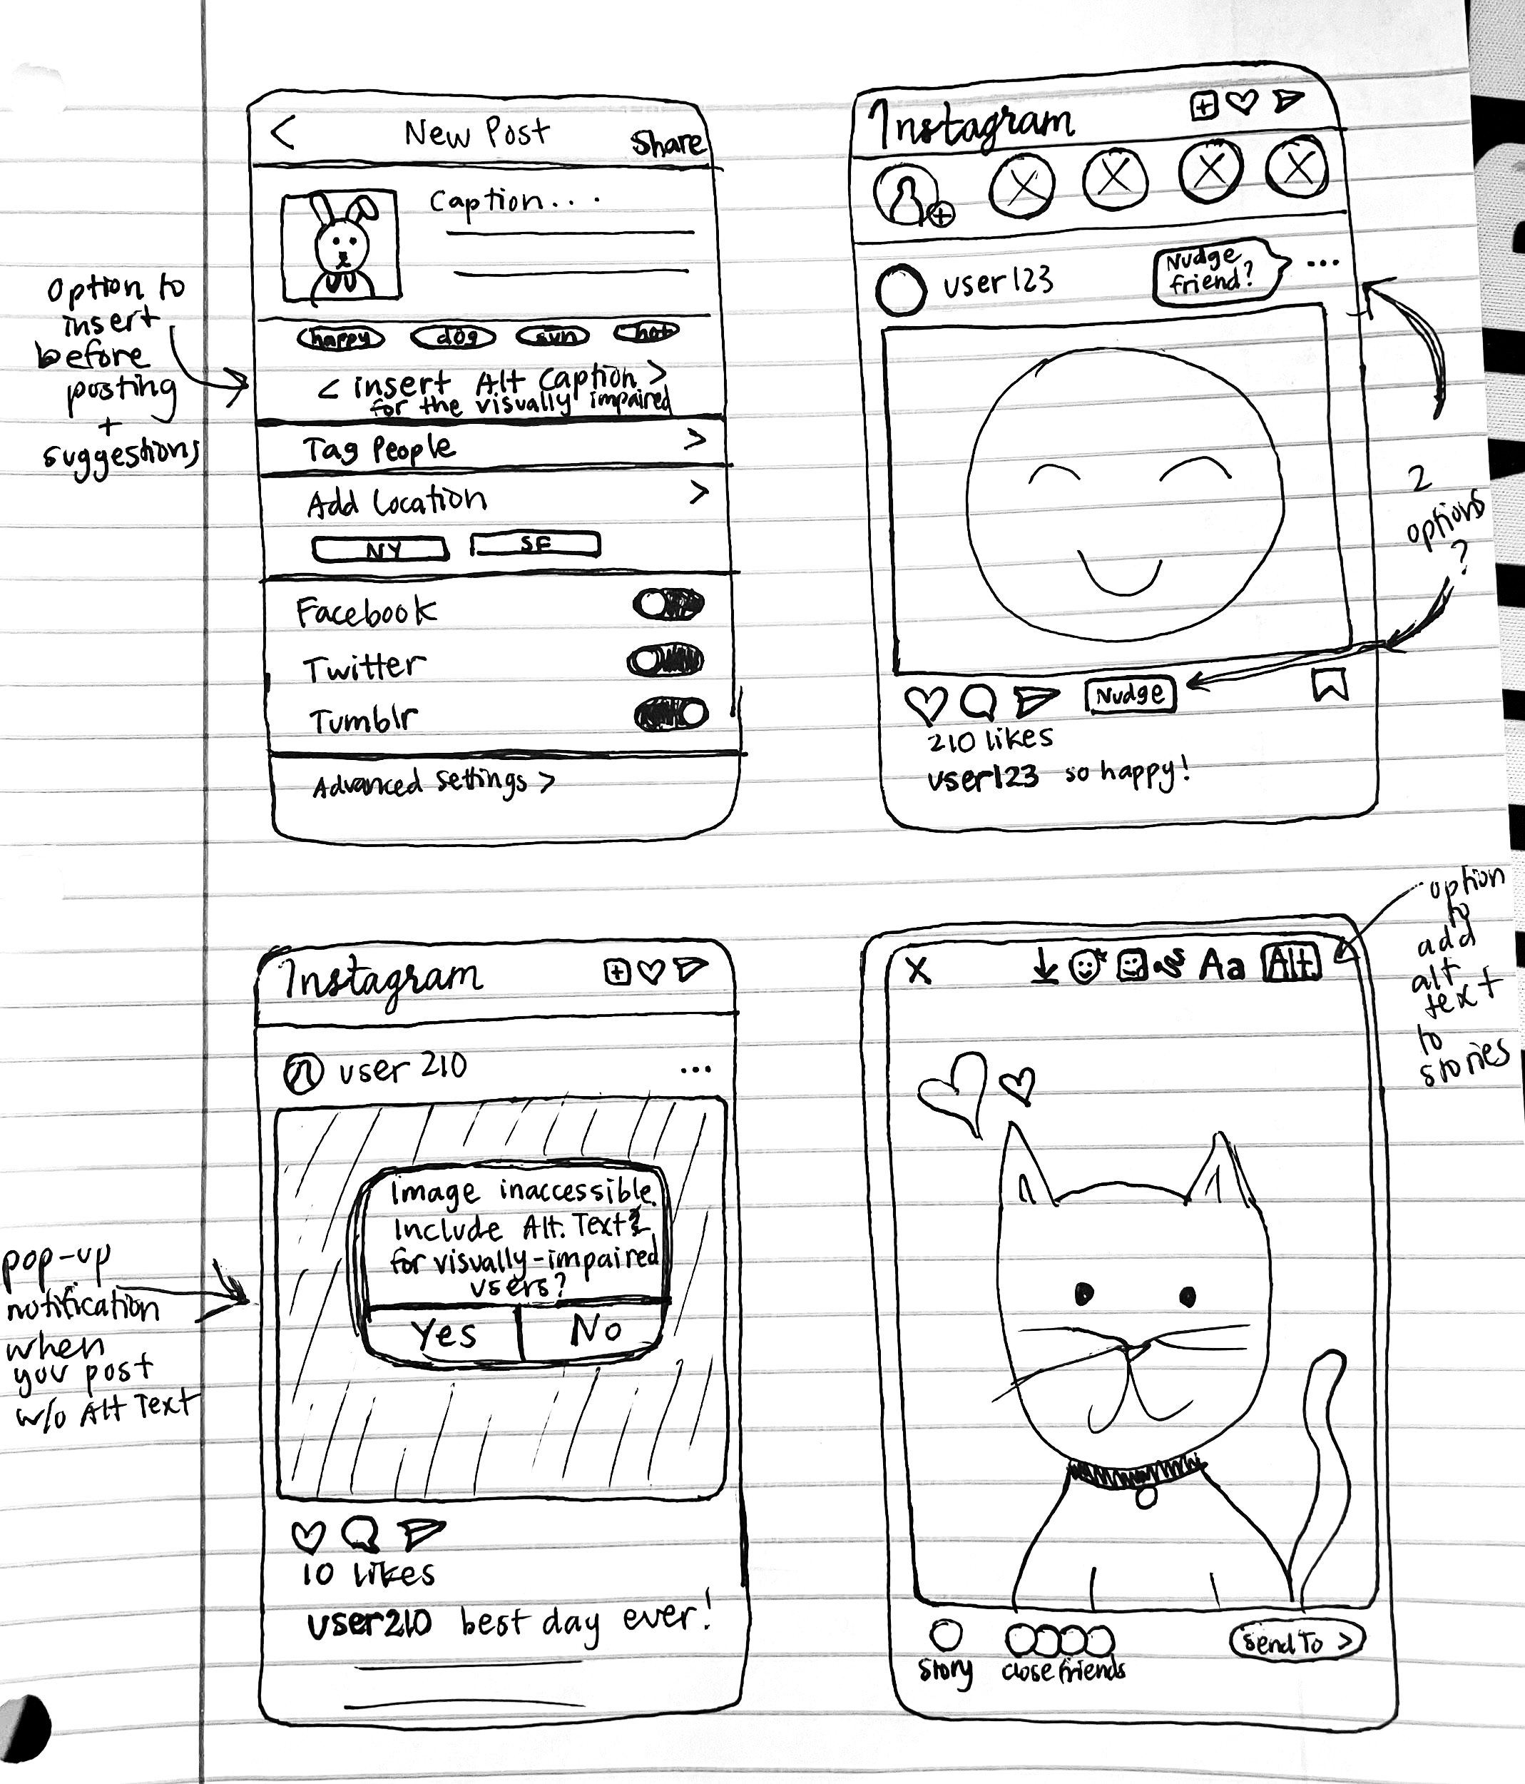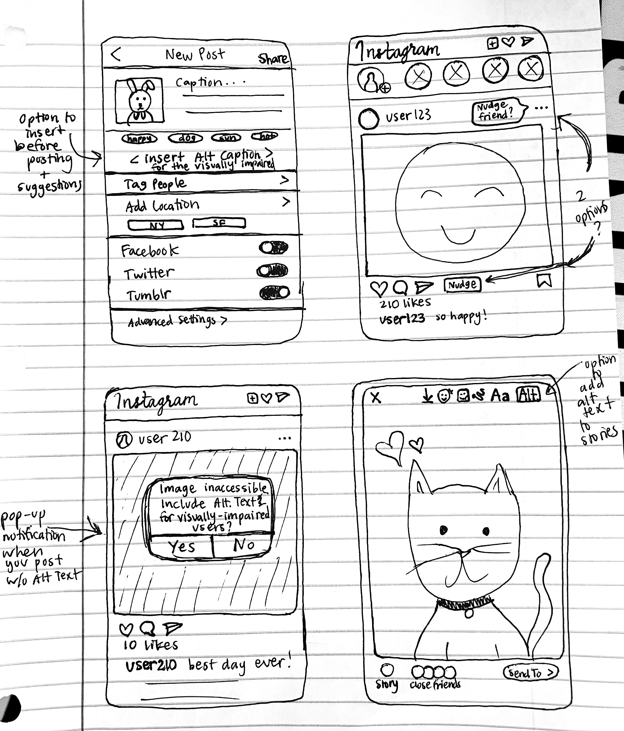
Figure 3: Instagram extension which is embedded into the app and integrates alt text reminders into learned and familiar Instagram interactions.

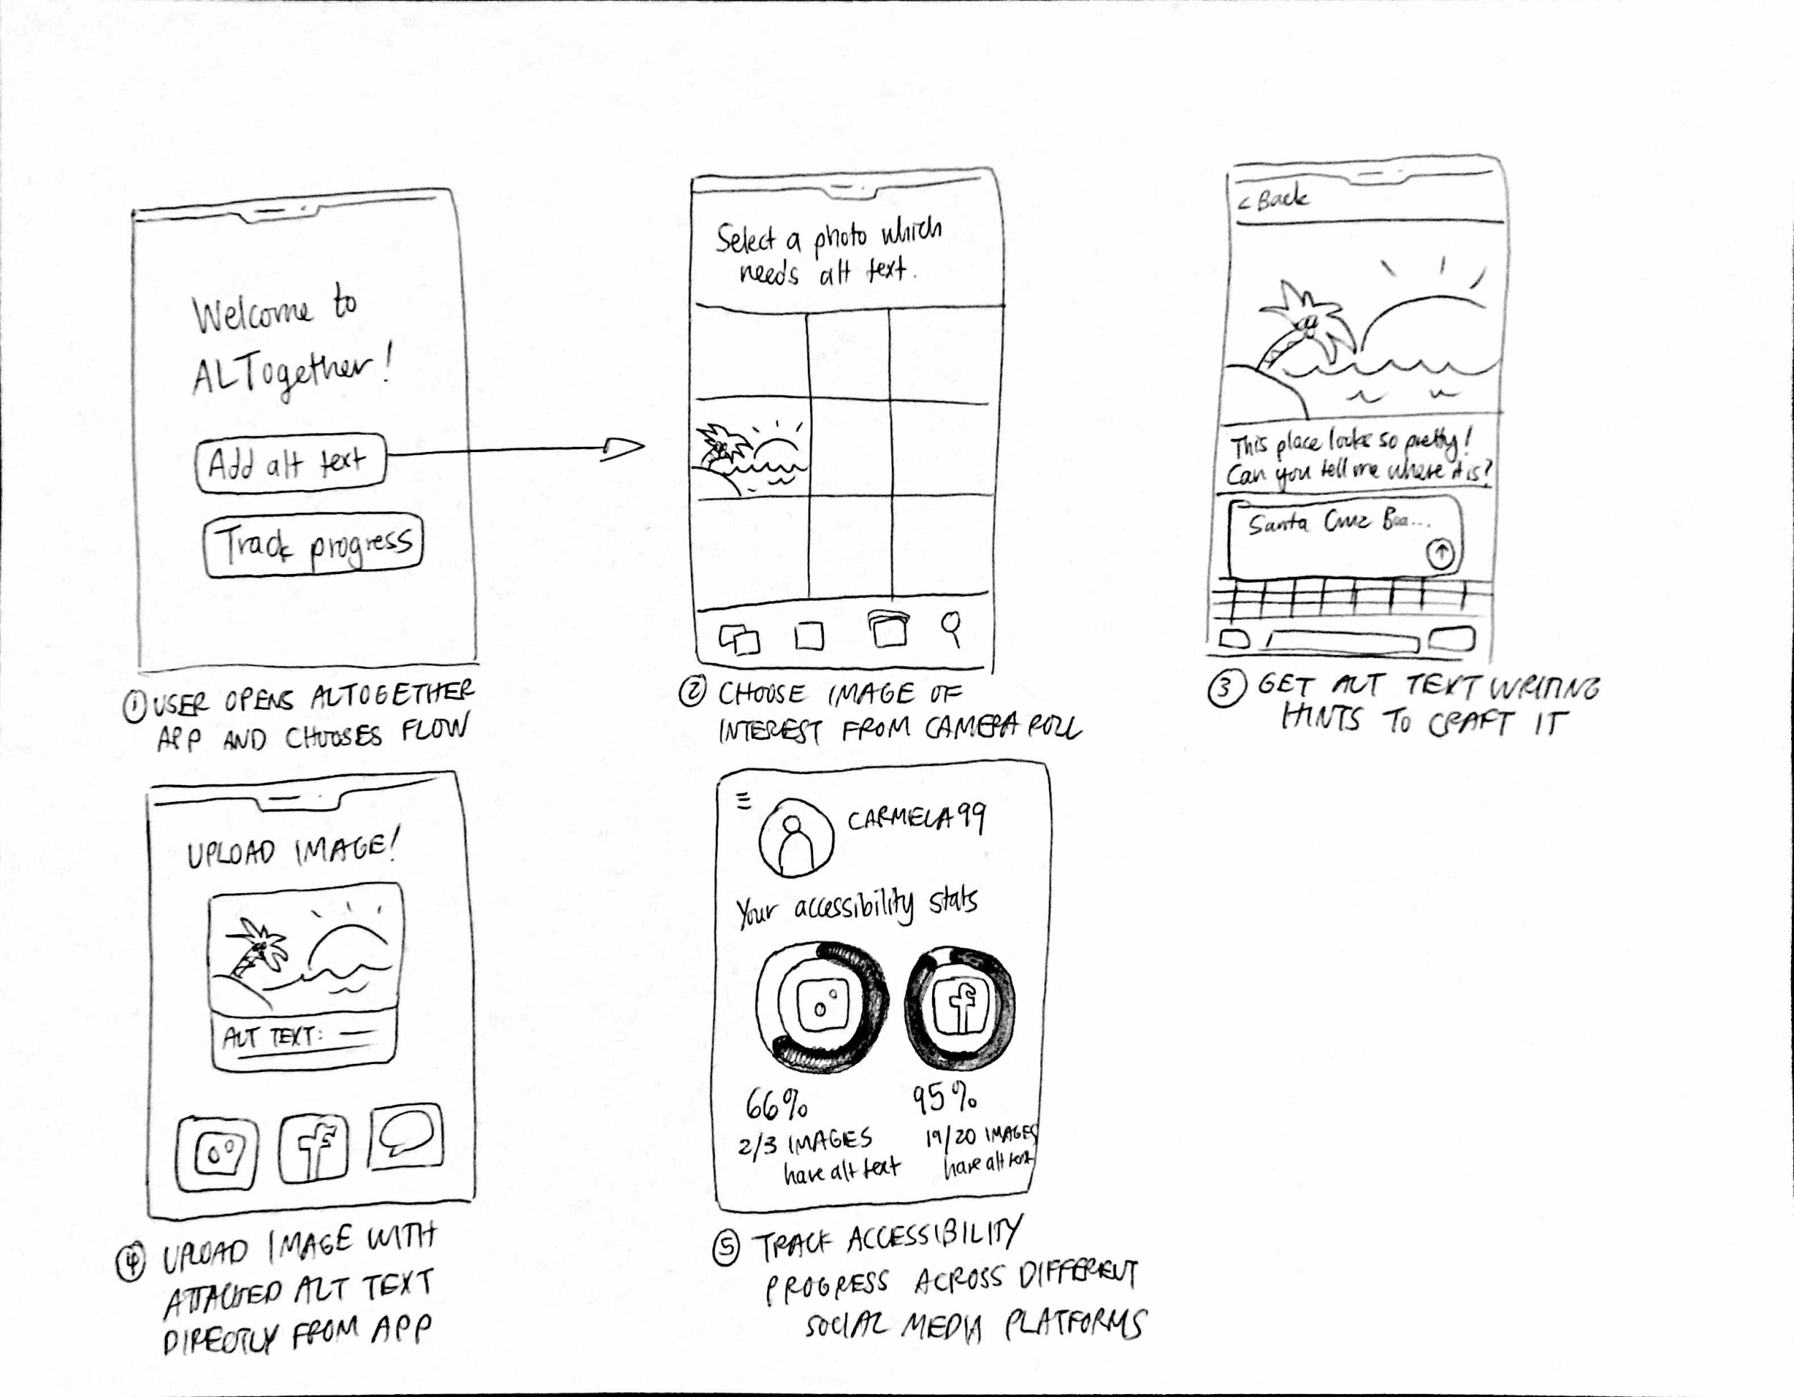
Figure 4: Separate mobile app where you can go for alt text writing tips before uploading to Instagram or Facebook. Sync with your social media to track accessibility progress.

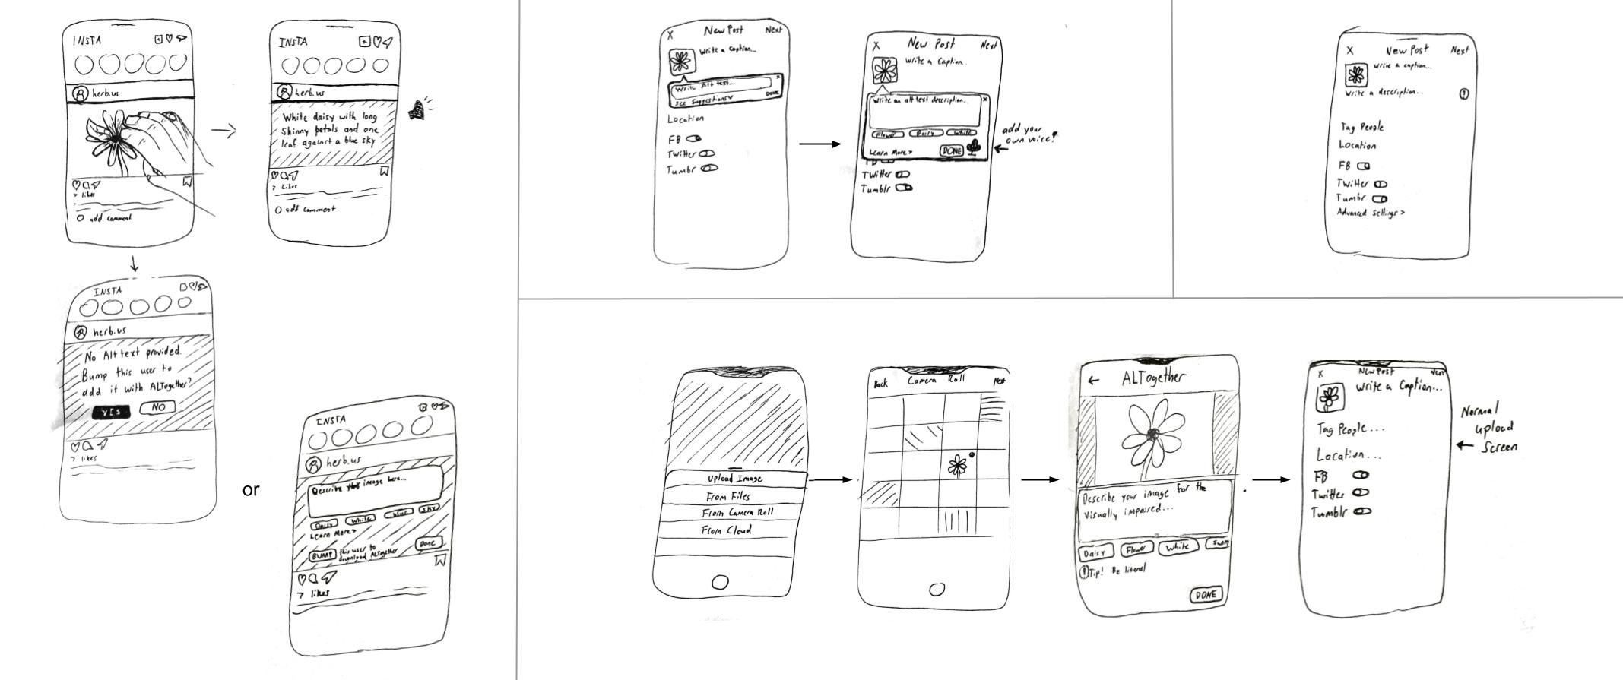
Figure 5: iOS extension that detects whenever you’re uploading an image and automatically prompts you to add alt text no matter what app or social media platform you’re on.

Top Design Storyboards

Top 2 Designs

After our initial sketches, we proceeded with our two most promising ideas: an Instagram Extension that brings alt text to the forefront of the platform, and a Camera Extension that auto-generates alt text in real time. Below are more detailed storyboards of both designs.

Design A: Instagram Extension

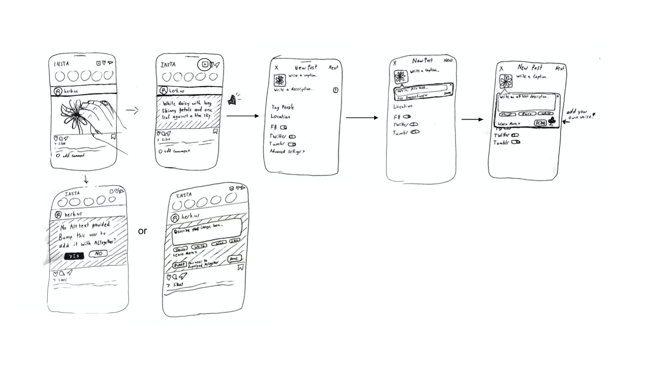
Figure 6: Flow of interactions within the Instagram app to add alt text to captions during posting.

Pros | Cons
- Native integration into Instagram’s existing platform  - Automatic prompt every time you upload a photo  - Don’t need to take an extra detour to a separate app in order to write alt text  - Can display progress and tips on the main app | - Alt text capabilities limited to one specific social media platform  - Alt text might not be added to photo back in camera roll, won’t follow image anywhere it’s posted

Design B: Camera Extension

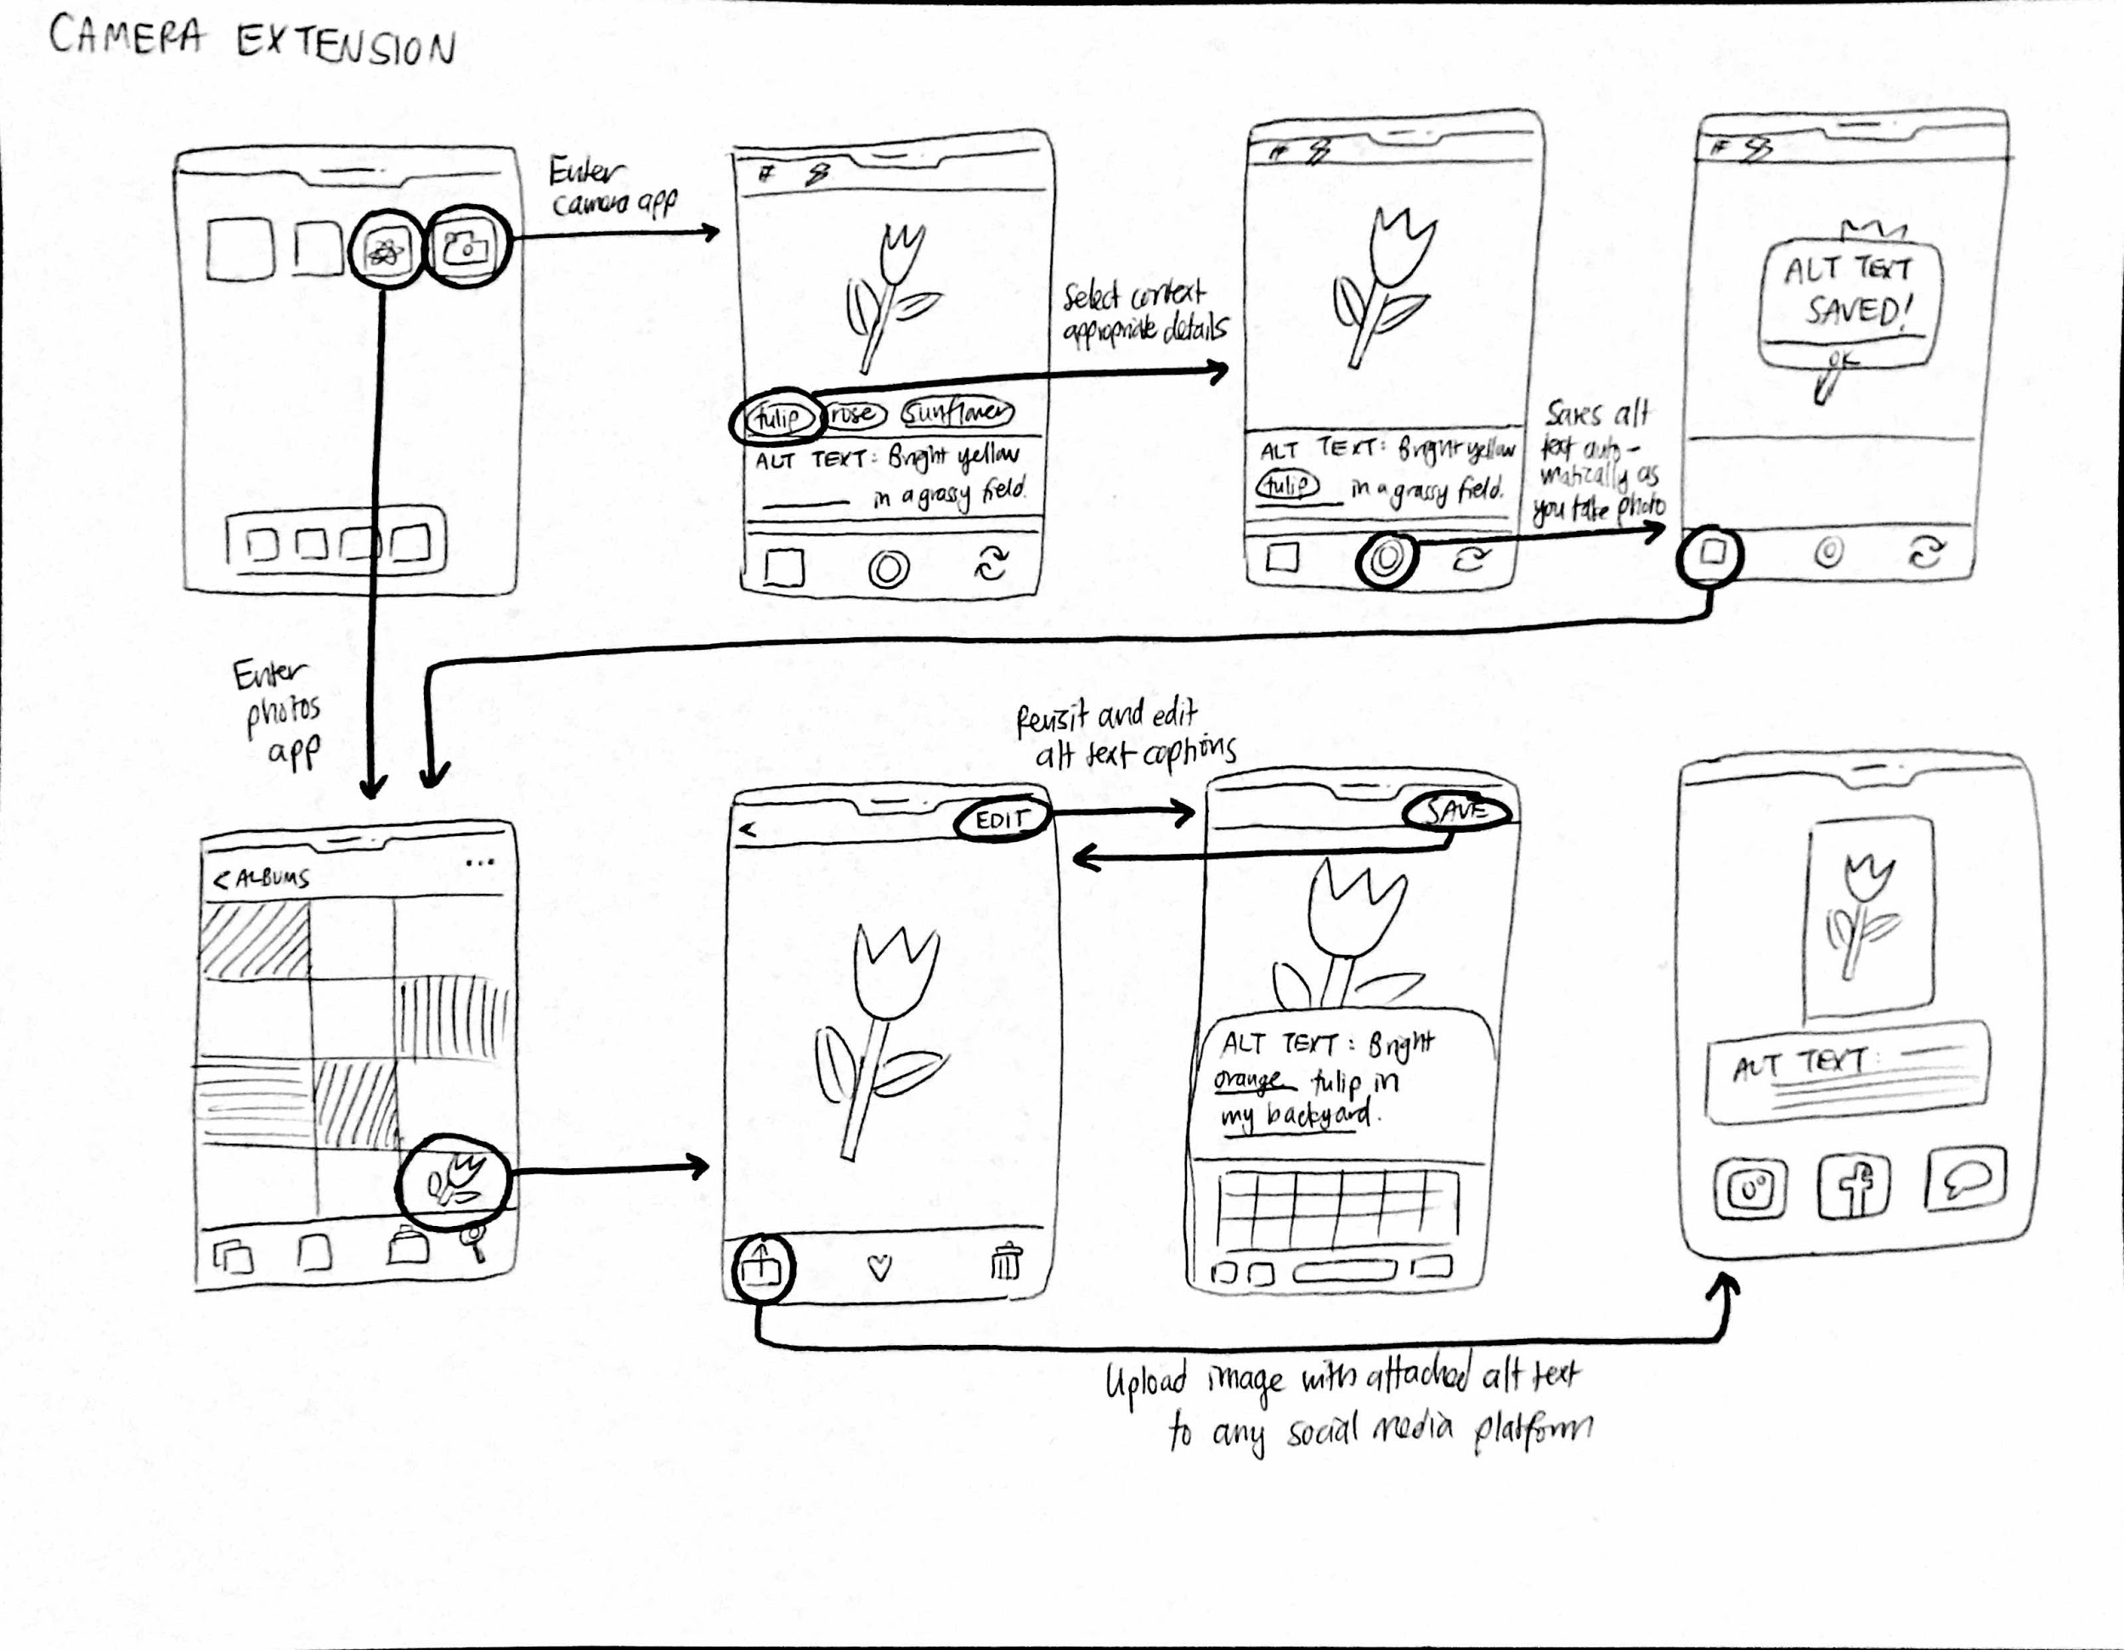
Figure 7: Flow of extension interactions between the camera and photos apps.

Pros | Cons
- Alt text is generated at the time of taking the picture, so won’t forget context surrounding picture  - Reduced burden by only adding alt text one picture at a time  - Alt text automatically attached to all photos in camera roll, will follow the photo anywhere you upload it | - Might be easy to bypass the alt text writing process when taking pictures in a rush  - Appears a bit clunky to have text popping up on camera interface  - Computer vision software may be inconsistent in generating reliable alt text in real-time.

Selected Interface Design

Rationale for Instagram Extension

Ultimately, our team believed an Instagram extension was more aligned with our goals and values over a camera extension. Even with the advancements in computer vision technology, auto-generated alt text is still very inaccurate and unreliable compared to user-generated alt text. Additionally, we recognized that sighted users would prefer writing alt text for an image they are uploading to social media rather than have alt text be auto-generated for every single picture they take, especially when most of them will never be shared publicly. Finally, with Instagram being predominantly image-based, it runs the risk of being the least accessible with a lack of alt text. Thus, we wished to significantly increase the accessibility of the most popular photo-sharing app.

Storyboards for 3 Task Flows

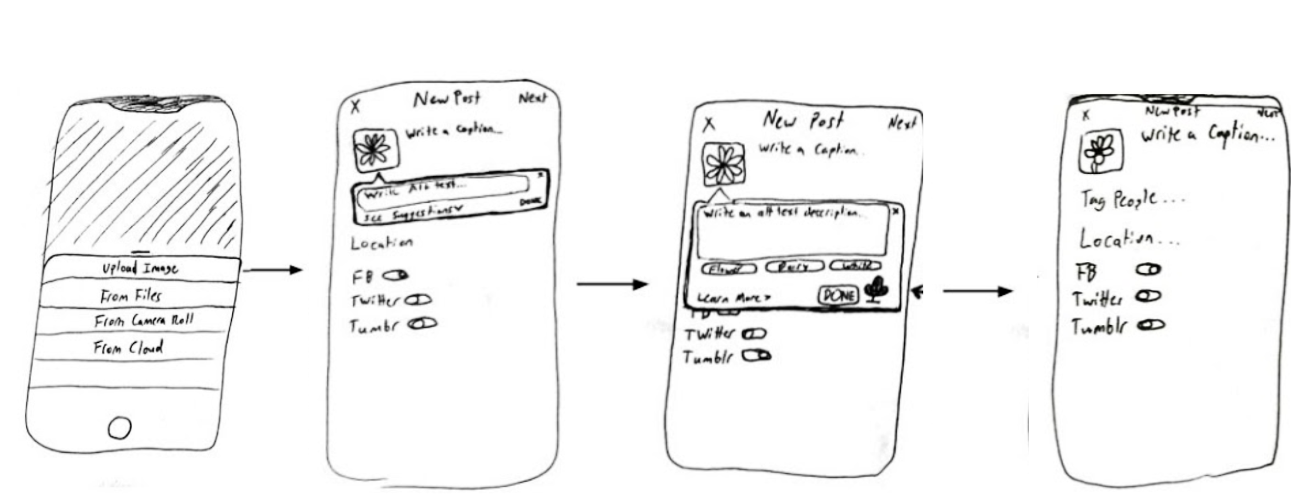
Figure 8: Simple Task: Sighted users are reminded to write alt text and can find where to write it in the first place.

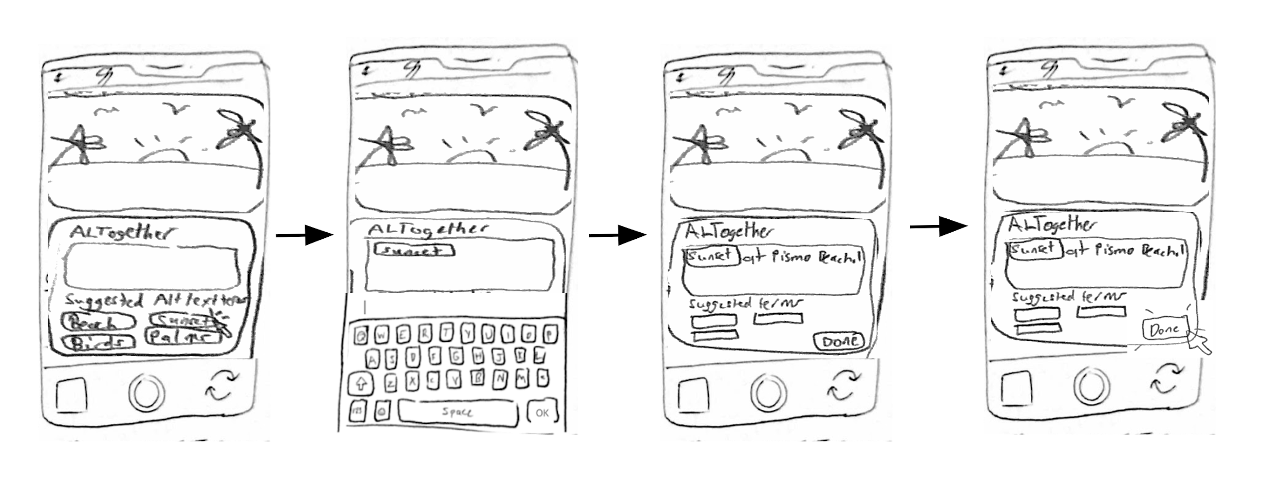
Figure 9: Moderate Task: Sighted users modify auto-generated alt text suggestions to add personalized context to their images.

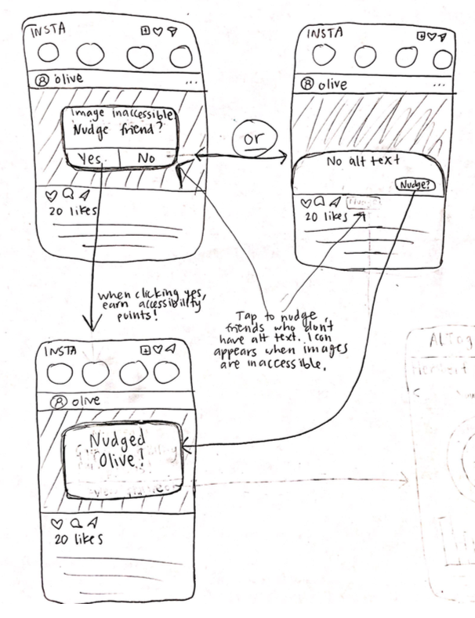
Figure 10: Complex Task: Sighted users identify which photos lack alt text and encourage friends to add their own personalized alt texts.
Low-Fi Prototype

We sketched screens and uploaded them to POP to have users interact with the prototype on their own device. The prototype simulates an easier alt text writing experience within the current Instagram UI supplemented by features defined for our 3 main tasks.

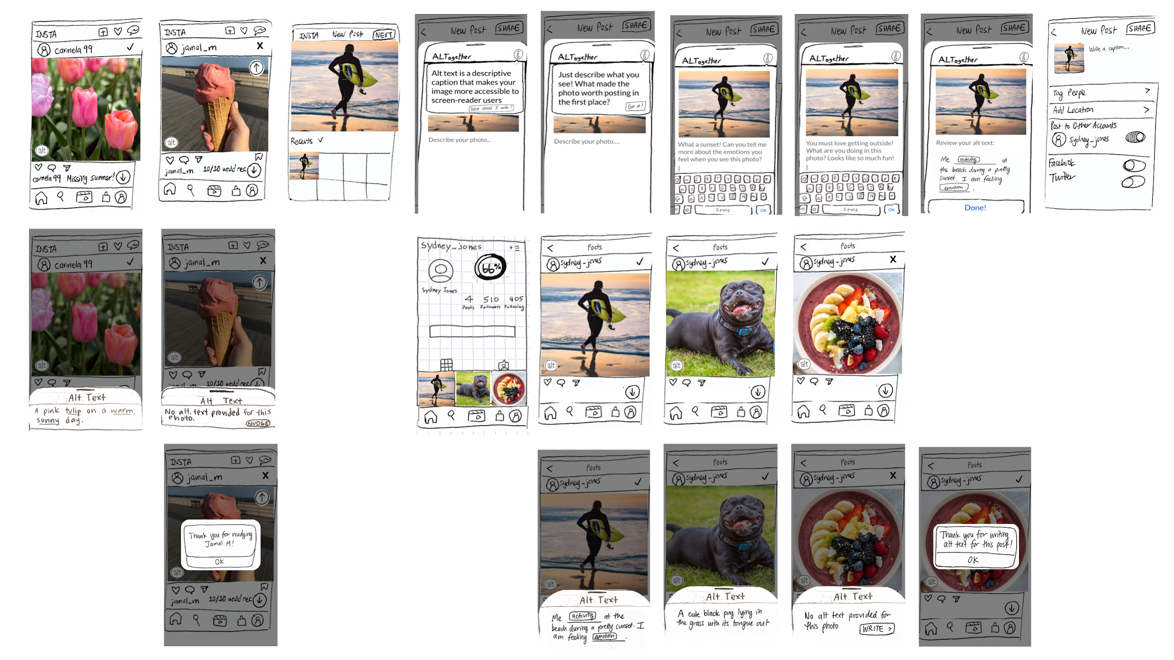
Figure 11: All screens of the prototype including interactive buttons and pull up screens.

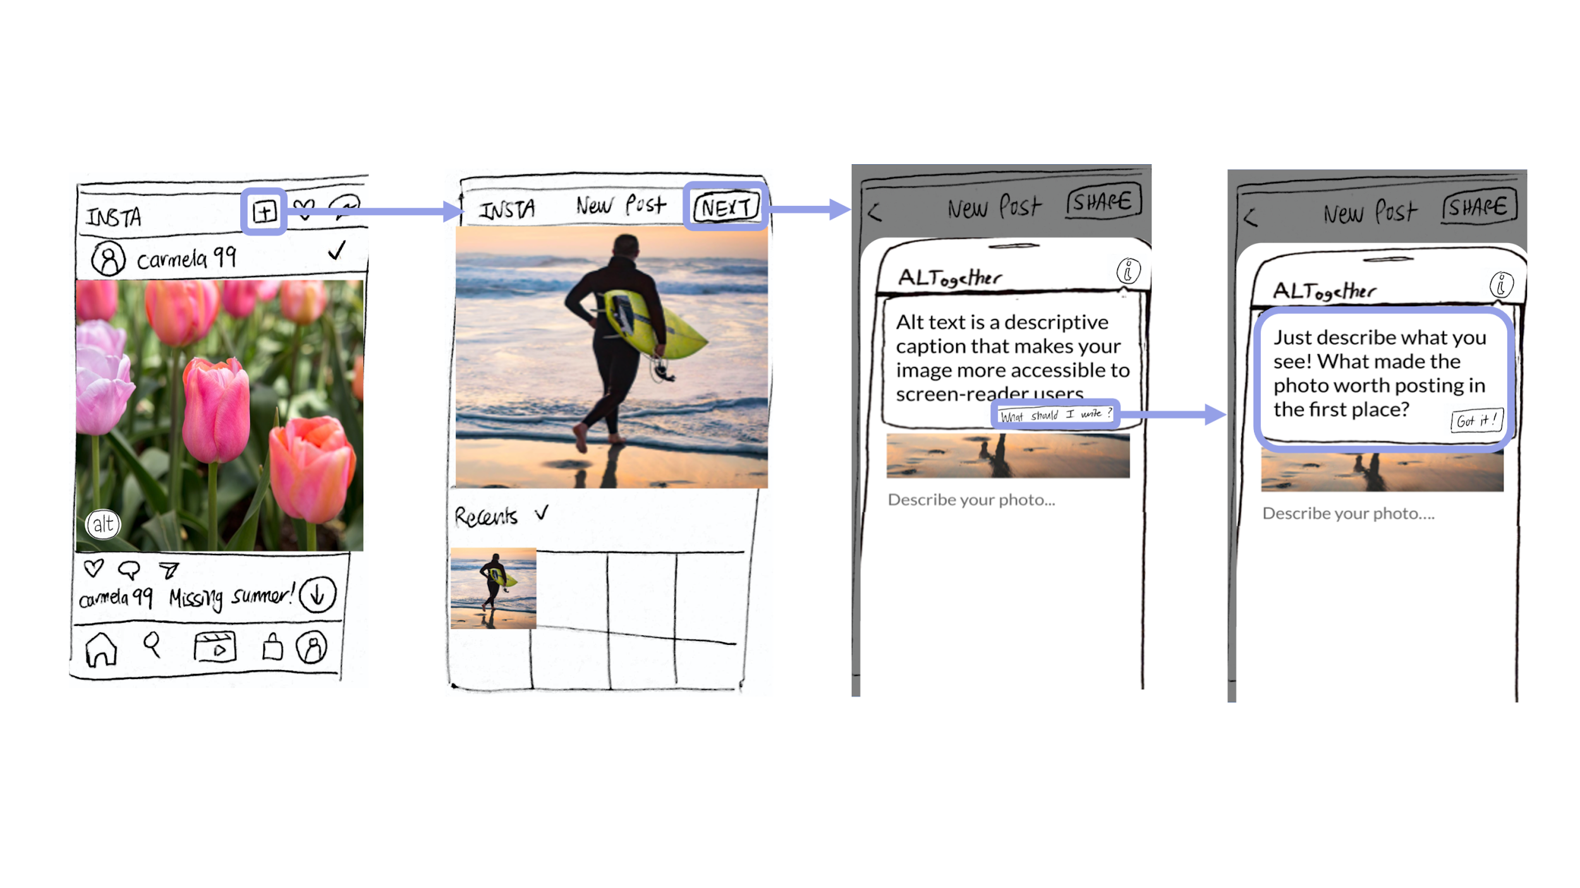
Figure 12: Simple Task: Sighted users are reminded to write alt text and can find where to write it in the first place.

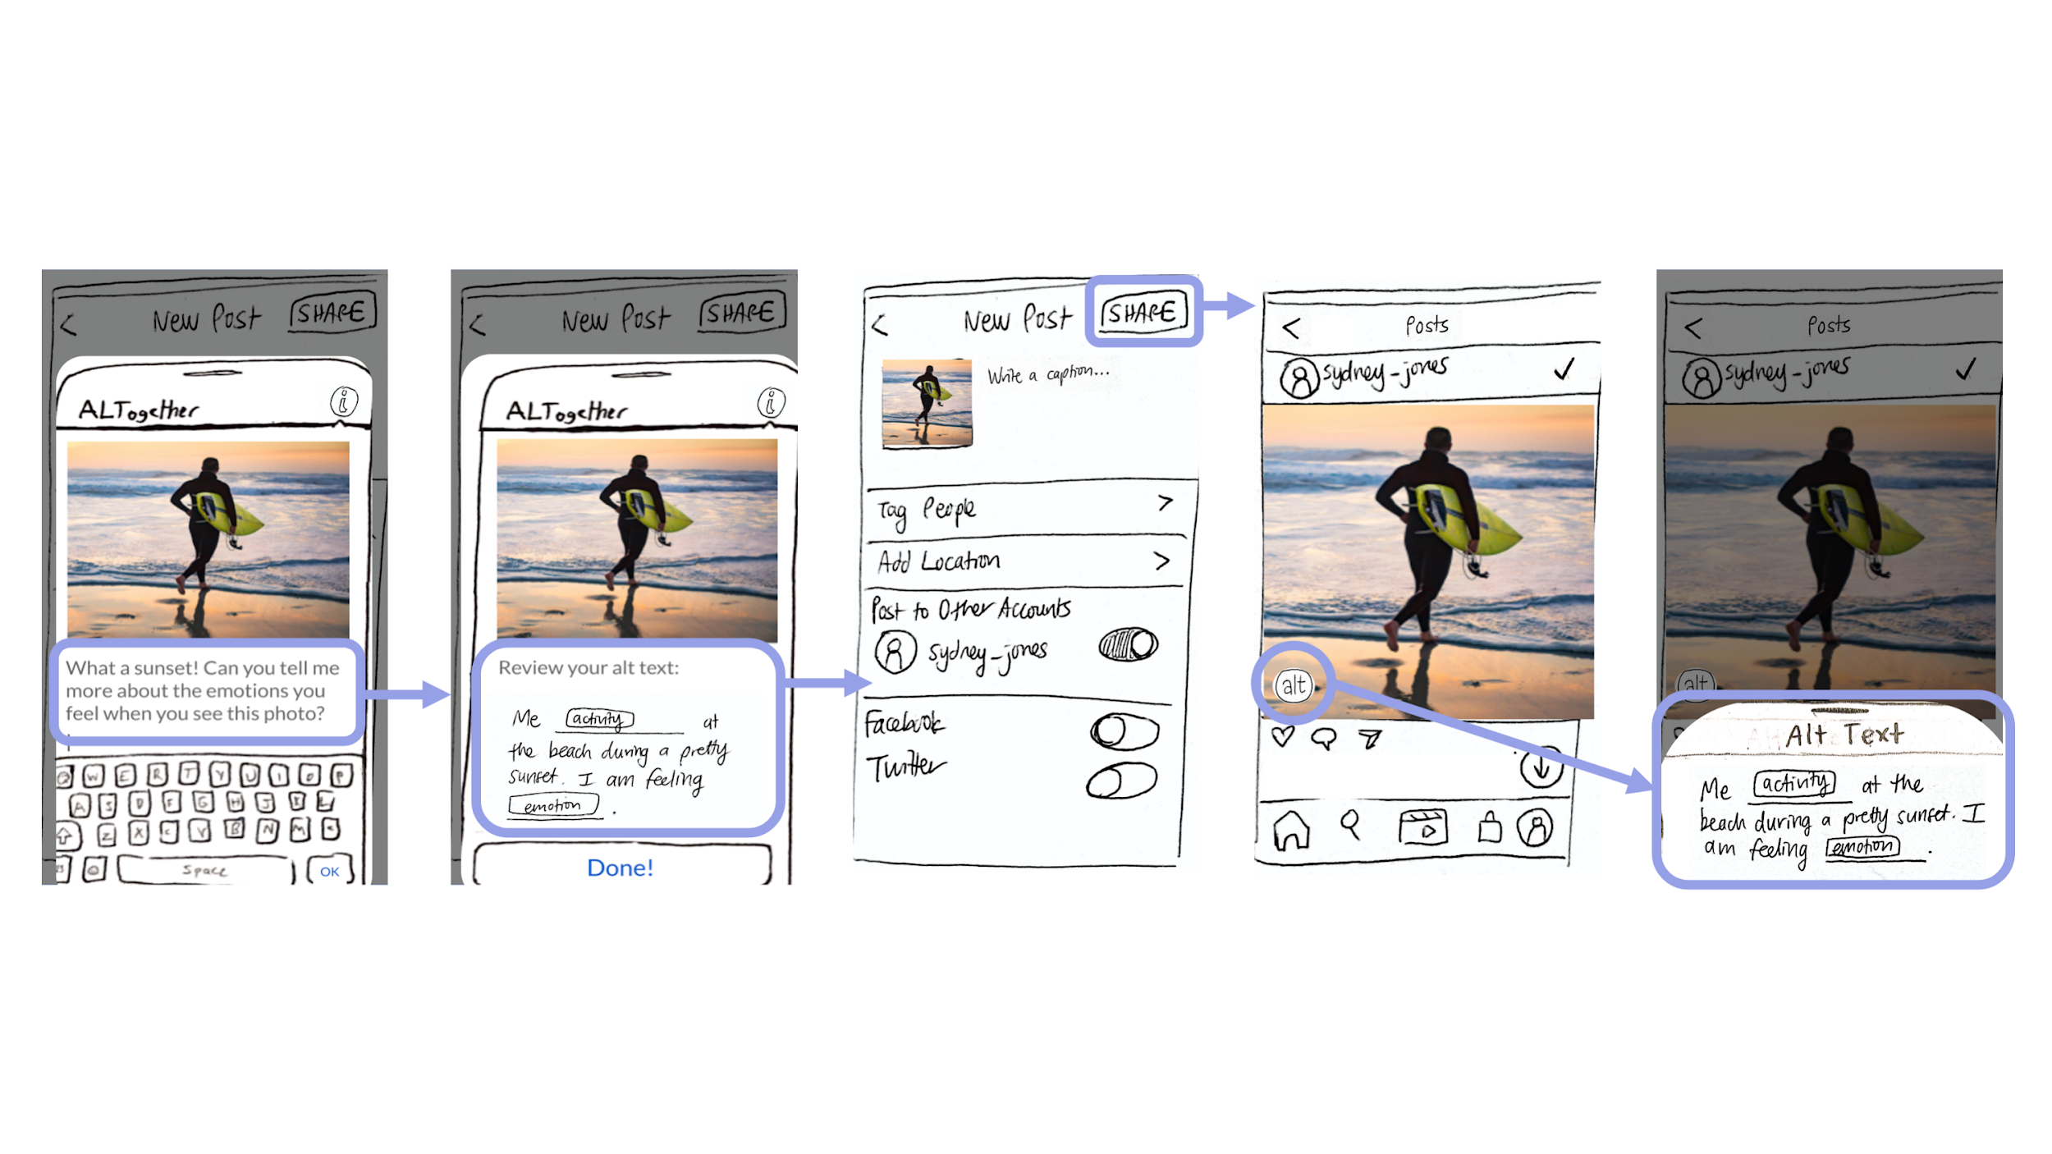
Figure 13: Moderate Task: Sighted users modify auto-generated alt text suggestions to add personalized context to their images.

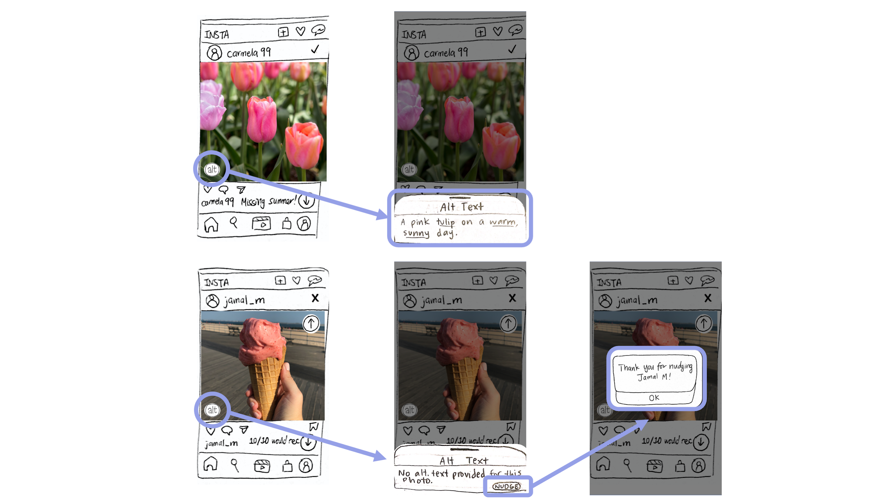
Figure 14: Complex Task: Sighted users identify which photos lack alt text and encourage friends to add their own personalized alt texts.

Elements | Functionality
“alt” button | Tap to find alt text “pull up screen”
pull up screen | Shows existing alt text or indicates its absence and the option to “nudge”
“NUDGE” button | Tap to notify the original poster that their particular image does not have any alt text
“✓/𝗫” icons | Indicates whether an image has alt text or not
up/down arrow buttons | Tap to scroll up or down in the feed
% Progress Icon | Indicates what percent of the user’s posts have alt text written for them
Testing Methodology

Participants

We chose three participants who had varying degrees of familiarity with using Instagram. They were all different ages and had different backgrounds, which gave us insight into possible variabilities in user preferences.

- Nina (23 y/o) : A dental student who we considered to be a “common user” of Instagram.
- Afreen (25 y/o) : An Instagram influencer who we considered to be a “power user.”
- Aimee (55 y/o) : A business owner who we considered to be an “older user” with less Instagram familiarity.

Environment

Our interviews were conducted through a Zoom call. We used POP to simulate our low-fi prototype, which the users interacted with on their phones while sharing their screen.

Tasks
- Upload a photo using alt text
- Find photos with alt text on their personal profile feed and view accessibility progress
- Find photos without alt text on friends’ feed and nudge them to include it

Procedure

We began our interview by introducing ourselves and giving participants an overview of our product focus on internet accessibility. After getting their consent, we clarified that this test wouldn’t be a measure of their aptitude, but was just to observe their interactions with the prototype. Users then navigated our mobile prototype on POP, as we asked them to execute a handful of different tasks, as specified above. After probing for their reactions, we told them our mission statement and asked them for any sort of feedback.

Test Measures

Success
- User demonstrates an understanding of what alt text is and how the new features increase accessibility.
- Alt text writing process seems quick, intuitive, and low-effort.
- User identifies alt text on uploaded images and encourages others to add alt text.

Error
- Big picture of image accessibility and where alt text fits into that is unclear or confusing.
- Alt text writing process seems unfamiliar and frustrating; posting a photo with alt text takes significantly longer than posting without.
- User cannot identify alt text on personal /others’ images on their own.

Team Member Roles

Greeter + Computer: Dani
Facilitator: Haeli, Sydney
Observer: Jung-Won, Sydney

Experimental Results

Because our selected users represented a range of ages and familiarity with Instagram, they each provided helpful insights into the successes and areas for growth in our prototype.

- All 3 consistently confused alt text with regular captions.
- All 3 quickly clicked through the alt text explanation and missed important details.
- All 3 incorrectly guessed what the accessibility tracker was.
- All 3 found the alt text prompts helpful and preferred them over starting from scratch.
- All 3 expressed positive feelings toward writing alt text after understanding it made their images more accessible to blind users.
- 2 users successfully found alt text on friends’ posts.
- 2 users expressed not knowing what screen readers were, and 1 user correctly guessed that it reads text on the page (but didn’t know it was an assistive tool for blind users).
- 2 users liked the “alt” button placed on top of the posts while 1 user wished it was re-located next to the captions.
- 2 users located “nudging” / “add alt text to photo” features but did not click them.
- 1 user confused “nudging” with liking a friend’s posts.

Discussion

By observing users’ interactions with our prototype, we were able to uncover misguided design choices and validate many of the assumptions we made.

Our greatest finding was that sighted users couldn’t easily distinguish between alt text and regular captions on images. Language like “screen reader users” was too unfamiliar for users to realize that alt text is a tool of accessibility, so in our next prototype, we would like to include more explicit terms like “blind” or “visually-impaired” to communicate its purpose. Our users’ demonstrated lack of alt text awareness only further highlighted this need for a clearer alt text onboarding process in our next prototype.

Additionally, we validated our assumption that writing alt text isn’t primarily a question of time or effort but rather of awareness. Once users understood what alt text was, they liked the idea of writing it to make their feeds more accessible to blind users. Including this clearer, more explicit language will also help emphasize the benefits of writing alt text to make a more accessible, more inclusive online community, further incentivizing sighted users to add it.

We also found that many users clicked through our alt text reminders relatively quickly without reading the given explanations, consequently missing a few key details about what alt text is and how to write it. Therefore, we plan to merge all of the alt text pages into a single scrollable screen, so that users must more intentionally interact with the prompts rather than mindlessly click through them.

Last, we initially aimed to seamlessly introduce and integrate new concepts like “alt buttons” or “nudging” with existing Instagram features and functionality. However, rather than see these concepts as seamless additions, many users confused them with already existing functions like captions, comments, and likes. Moving forward, we aim to minimize the introduction of new symbols and merge ideas like the “✓/𝗫” and “alt” icons into a single feature to reduce unfamiliarity. Overall, our team must determine how to make our extension seamless enough to integrate within Instagram while keeping it distinct enough so as not to be confused with other features.

(Word count: 1490)

